**Practical task**

1. Based on AJAX technologies, write the client part of the application ( HTML + JavaScript ), in which, when you click on the button, an asynchronous GET request is sent to the server, the server processes the request and sends it to the HTML page, updating the content of the button as shown in the example .

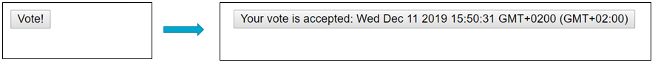

2. Based on AJAX technologies, write the client part of the application ( HTML + JavaScript ), in which, when a button is pressed, an asynchronous GET request is sent to the server, the file books is downloaded . json and it displays all authors' names in the form of a list on an HTML page.

